Welcome to AtomicMVVM

[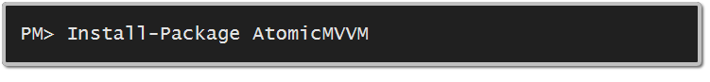](https://nuget.org/packages/AtomicMVVM)

The goal of AtomicMVVM is to allow developers to work with MVVM in their XAML based solutions (XPF, Silverlight, Windows Phone, WinRT) with minimal effort while not getting in the way of the code. It requires .NET 4 or higher.

# Index

* Feature Set
* Design
* Getting started
* Attributes
* Global Commands
* License
* In the Wild
* Change Log
* Known Issues

# Feature Set

AtomicMVVM supports the following MVVM features:

* The bootstrapper handles injection of views into a shell, so you don’t have to.
* The bootstrapper handles joining and creating of views and view models, so you don’t have to.
* No more commands, just normal methods.
* No more CanExecute (ICommand again) worries, just normal methods.
* Can easily link the methods to the properties change notification, so you can update CanExecute or fire off code in a single line!
* Can pass information from one view to another.

# Design

The design goals of AtomicMVVM are (in order): simple over feature rich, unobtrusive over less code and convention over configuration.

## Simple over Feature Rich

AtomicMVVM isn’t going to set the world on fire because rather than build something monolithic that can do everything, in every way we decided to focus on the core of MVVM and build for that. This means it easily slots into projects and the source code also easy to understand:

* It is two files on .NET 4 and one file on .NET 4.5
* It is less than 300 lines of code
* It has only one method with a cyclomatic complexity higher than 8

What we trade-off for this is features and options, so it only works one way and if you don’t like that one way there isn’t much you can do about it unless you change the code and because the code is so simple that isn’t hard either!

An example of this choice is that we do not support convention binding for controls (like textboxes) to properties. Rather we expect you to just use normal XAML binding, where you get all the powerful features of that without us having to reinvent it.

## Unobtrusive over less code

While other MVVM frameworks allow you to do amazing things by writing TINY amounts of code, a lot of the time you take a penalty for that in the way of having a lot of references, or class inheritance. The moment you are unhappy with something (like having to inherit from a specific class) then you are forced to write massive amounts of code (reinventing the wheel).

Rather than model, we have decided to be unobtrusive – for example to convert a normal WPF project to use AtomicMVVM means adding one interface to your Main Window (Shell), adding one static property and removing one line of XAML! So you may have a little more setup but in the end it gets out the way easier so you can easily use AtomicMVVM with anything you like.

## Convention over configuration

The final design goal is that there should be as little manual configuration as possible and that if you follow the convention (how we name things) then everything just works. This means the learning curve for you is very shallow, in fact we have only one configuration parameter that is required: What is the name of the shell class and what is the first bit of content to put in it!

# Getting started

We will start off with an empty WPF project; just to show you how easy it is to get started!

1. Grab AtomicMVVM from Nuget
2. Create two folders in your project, the first named Views and the second named ViewModels. 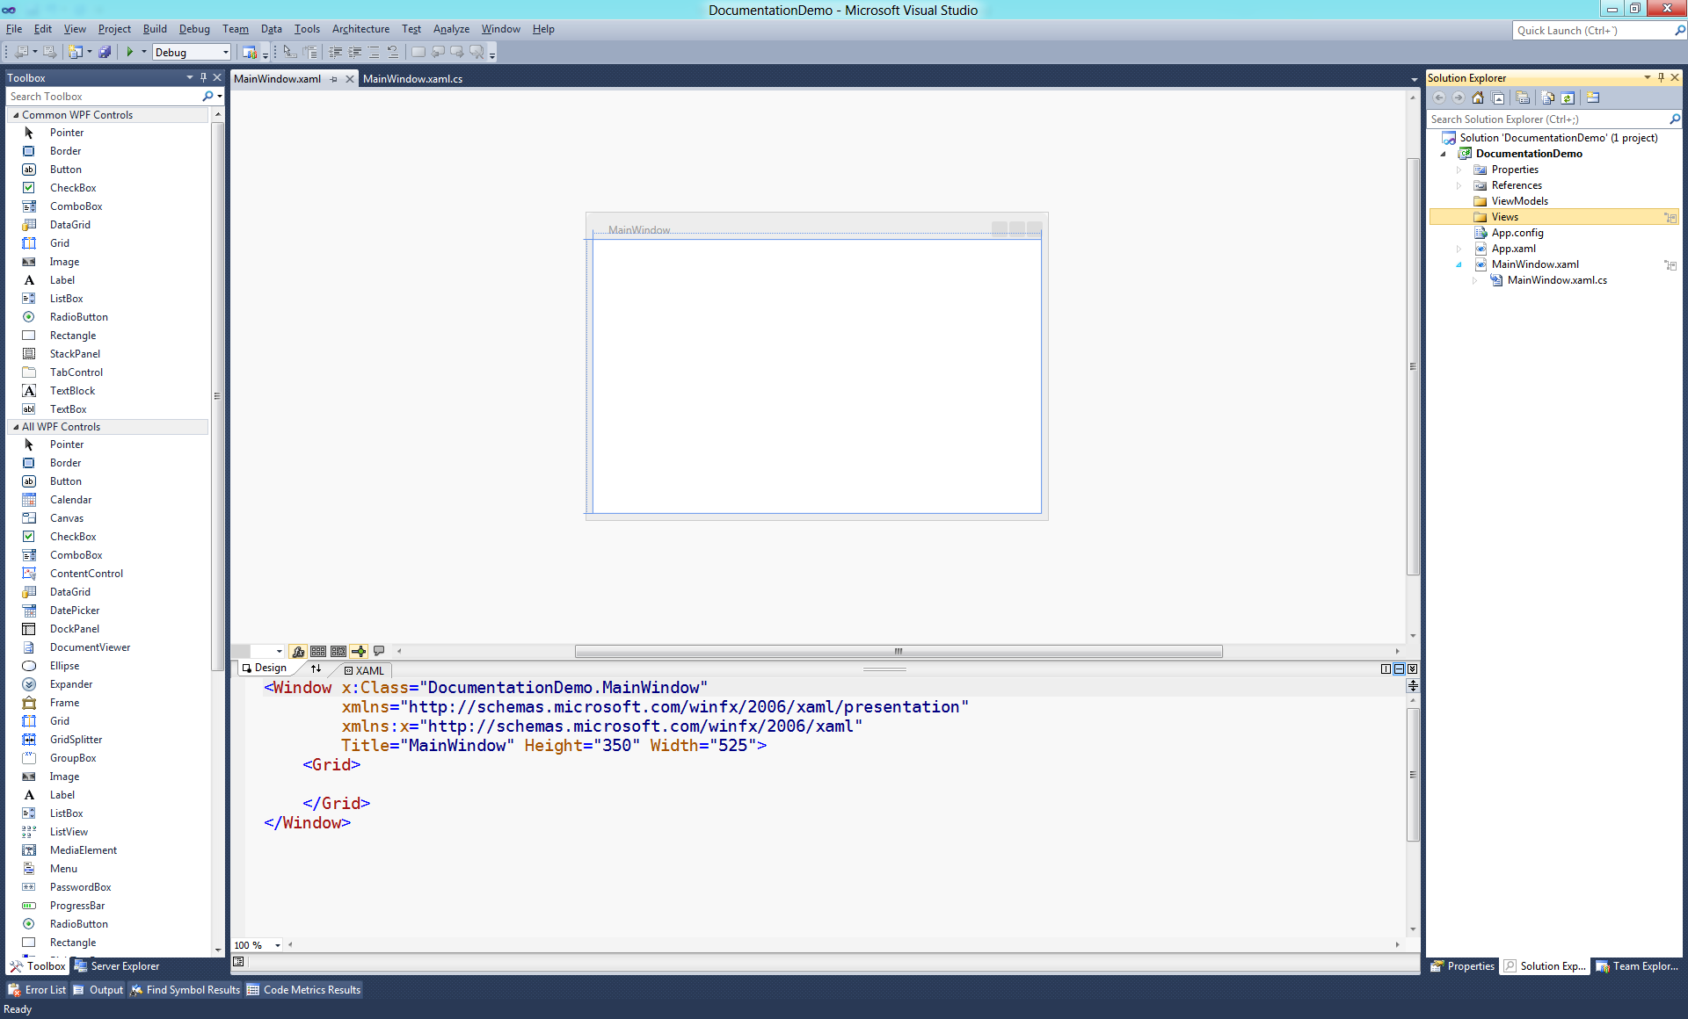

It is VITAL that these names are exactly correct or it will not work.

1. Open your MainWindow.xaml (this will be our shell) and replace the Grid with a named ContentControl.

<Window x:Class="DocumentationDemo.MainWindow"

xmlns="http://schemas.microsoft.com/winfx/2006/xaml/presentation"

xmlns:x="http://schemas.microsoft.com/winfx/2006/xaml"

Title="MainWindow" Height="350" Width="525">

<ContentControl x:Name="ContentPlacement"/>

</Window>

1. In the code behind for MainWindow.xaml, have the class inherit from IShell and implement the interface. It has one method which is used to set the content of our ContentControl when the view changes.

public partial class MainWindow : Window, IShell

{

public MainWindow()

{

InitializeComponent();

}

public void ChangeContent(UserControl viewContent)

{

ContentPlacement.Content = viewContent;

}

}

1. Now we will create the view model. Right click on the ViewModels folder and add a new public class that inherits from CoreData called Simple (i.e. Simple.cs). This view model has a Name property, a method that says hello and a method that states if Name is not null or white space.

public class Simple : CoreData

{

private string _name;

public string Name

{

get { return _name; }

set

{

_name = value;

RaisePropertyChanged("Name");

}

}

public void SayHi()

{

MessageBox.Show("Hello "+this.Name);

}

[ReevaluateProperty("Name")]

public bool CanSayHi()

{

return !string.IsNullOrWhiteSpace("Name");

}

}

Notes:

1. The Name property calls RaisePropertyChanged, which is a helper method to INotifyPropertyChanged.
2. The name of the SayHi method and its signature (returns void, takes no parameters). This is important for the convention based binding for commands.
3. The name of CanSayHi method, it’s convention of the Can prefix, and its signature (returns Boolean, takes no parameters). This is important for the convention based binding for commands.
4. The ReevaluateProperty attribute which tells the bootstrapper that when the Name property changes the result of this method changes too.
5. Now for the view, right click on the Views folder and add a UserControl named Simple (i.e. Simple.xaml) and in there we add the XAML to enter a name and click a button.

<UserControl x:Class="DocumentationDemo.Views.Simple"

xmlns="http://schemas.microsoft.com/winfx/2006/xaml/presentation"

xmlns:x="http://schemas.microsoft.com/winfx/2006/xaml"

xmlns:mc="http://schemas.openxmlformats.org/markup-compatibility/2006"

xmlns:d="http://schemas.microsoft.com/expression/blend/2008"

mc:Ignorable="d"

d:DesignHeight="300" d:DesignWidth="300">

<StackPanel>

<TextBlock Text="Name"/>

<TextBox Text="{Binding Name}"/>

<Button x:Name="SayHi" Content="Say Hello"/>

</StackPanel>

</UserControl>

Notes:

1. We use normal binding for the Text property of the TextBox to the Name property of the view model.
2. The Button (which is an ICommandSource) name is the same as our method name in the view model.
3. Open the App.xaml file and remove the StartUri attribute. If you don’t, you’ll end up with two windows, one that works and one that is blank.
4. Open the App.xaml.cs file and add a public static property of Bootstrapper<TShell,TContent>. The first generic type is the class to use as the shell (i.e. our MainWindow) and the second is the default view model to load into the shell.

public partial class App : Application

{

public static Bootstrapper<MainWindow, ViewModels.Simple> Bootstrapper = new Bootstrapper<MainWindow,ViewModels.Simple>();

}

1. Press F5 and enjoy!

# Attributes

## ReevaluateProperty

In the getting started we introduced one attribute, ReevaluateProperty which is used on Can methods, i.e. methods that are prefixed with Can and tell the Command that is created if it can be executed. By adding these attributes to the method it tells the bootstrapper, which properties affect the Can method result. Note: You can have multiple ReevaluateProperty attributes on a method.

## TriggerProperty

The other attribute is called TriggerProperty and it is used in a similar way to ReevaluateProperty, except it causes the attributed method to fire when the property updates. This is useful for scenarios where one property change causes the value of other properties to change.

[TriggerProperty("SelectedMake")]

public void SetModels()

{

if (string.IsNullOrWhiteSpace(this.SelectedMake))

{

this.Models.Clear();

return;

}

var models = data.Single(_ => _.Name == this.SelectedMake).Data.Select(_ => _.Name);

UpdateCollection(this.Models, models);

}

An example of this is in the general demo app, in the Car Selector demo, where changing the Make dropdown changes the values of the Model and Colour dropdowns and changing the Model drop down changes the value of the Colour drop down.

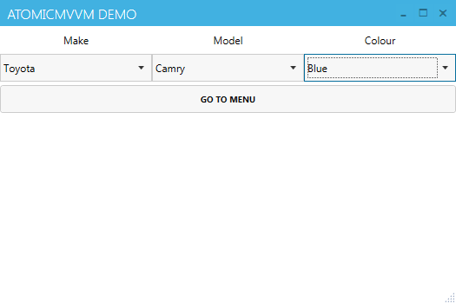

Note: It is possible to create an infinite loop, which will result in a stack overflow if the attributed method updates any of the properties that attribute it – so be careful.

This attribute may seem not to be a MVVM item and thus violates the first design goal, but this is so easily implemented with the bootstrapper and it is so common that any other way to do this would not be correct.

# Global Commands

The bootstrapper has a property named GlobalCommands which is a List<Tuple<string,Action>>. This list stores a set of global commands that can be used when the view model does not contain a method already. It works on a similar process, the name of the ICommandSource (for example a button) must match the string item of the Tuple, if it does and there is no command in the view model that matches it will run the action item of the Tuple.

Bootstrapper.GlobalCommands.Add(new Tuple<string,Action>("GoToMenu", () => App.Bootstrapper.ChangeView<Menu>()));

This is useful where you have a common set of commands that are used in many view models and you do not wish to repeat them in each view model.

An example of this is in the general demo app, where most views have a Button that allows you to return to the menu. The Button is always named GoToMenu and no view models have a method like that, so the global command is used rather.

# License

AtomicMVVM is released under a [MS-PL license](http://www.opensource.org/licenses/ms-pl.html959595), so that it’s friendly to developers of both open and closed source software.

# in the Wild

No one yet! Will you be the first to do it and let us know?

# Change Log

## 1.0.5

* Added support for non-default view constructors which allows for data passing.
* Added support for global app commands.

## 1.0.4

* Building for .NET 4 client profile now (rather than 4.5 as was doing).

## 1.0.3

* Doesn't help if I don't include the updated assembly. So this is 1.0.2 proper.

## 1.0.2

* Updated project to be the bitbucket site.
* Helps if I make classes public (doh).
* Added trigger property logic.
* Fixed bug in the type location.

## 1.0.1

* First release.

# Known Issues

No known issues! That either means there are none (because we are awesome) or no one has reported any!